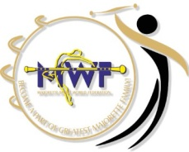
MWF- MAJORETTE-SPORT WORLD CHAMPIONSHIP–POREČ,22.-25.09.2016.
APPLICATION FORM
DEADLINE 20. 09. 2016.
E-mail: majorettes.cro@gmail.com
-payment of 100% on accreditation
Adress: SAVEZ MAŽORETKINJA I POM-PON TIMOVA HRVATSKE
Bank account: RBA Raifeissen bank Austria d.d.
IBAN HR922 484 0081 101 900 360
SWIFT: RZBHHR2X
TEAM:

DVD:
DAY: | NUMBER | TOTAL:
1. day / 15,00 EUR
2. day/15,00 EUR
3. day/15,00 EUR
4. day/ 15,00 EUR
ALL DAYS-45,00 EUR
ALL:

Date:_____________________ ______________________
Signature:

