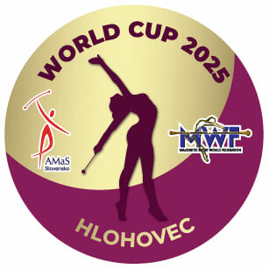
WORLD CUP
HLOHOVEC, SLOVAKIA /8.-9.11. 2025
APPLICATION FORM
FOOD
DEADLINE – 28.10.2025/ EMAIL: foodhlohovec@gmail.com

We present you the catering offer at the World Cup 2025 Hlohovec sports event. The menu is attached. Please choose from the offer.
If you are interested in a meal from the offer, please send it to the e-mail:
foodhlohovec@gmail.com by 28.10.2025.

Payment for the meal will be possible in cash in euros upon registration.
Lunch price: 8 EUR
Dinner price: 7.50 EUR

During the competition, catering zones will be created in the interior and exterior of
the sports hall. The distribution of food will be coordinated with the start list.
Group catering will also be possible by agreement in the Lukras restaurant, which
provides catering - approximately 500 m from the sports hall.

team:

contact person:

e-mail:

mobile:

data for invoice:

DATE | LUNCH-A/ B | DINNER-A/B | TOTAL
07.11. 2025
08.11. 2025
09.11. 2025
ALL:

Date:_____________________ Signature:______________

